SCED 372 2020 SPRING FINAL EXAM RULES and REGULATIONS

Please read carefully and follow the rules during the exam to take place on the 11th of July 2020 between 12:30-15:00.

- The exam will be held on Zoom, and you’ll be expected to log onto a Zoom meeting from the link in our SCED 372 moodle page.
- You will need a laptop or a computer, with a camera and speakers/mic. You’ll also need a reasonably good internet connection. Please try to make sure you are somewhere providing these. You’ll need this device for logging onto Zoom. Zoom will only be used for proctoring purposes. You’ll write your exam on A4 papers. The exam will not be online. You are not allowed to use earphones (kulaklık) during the exam.
- Please position the computer that you are logging onto Zoom where we can see you sitting at a table with only one empty sheet, pencil, eraser, water, candies etc but nothing else. (See sample photo below)
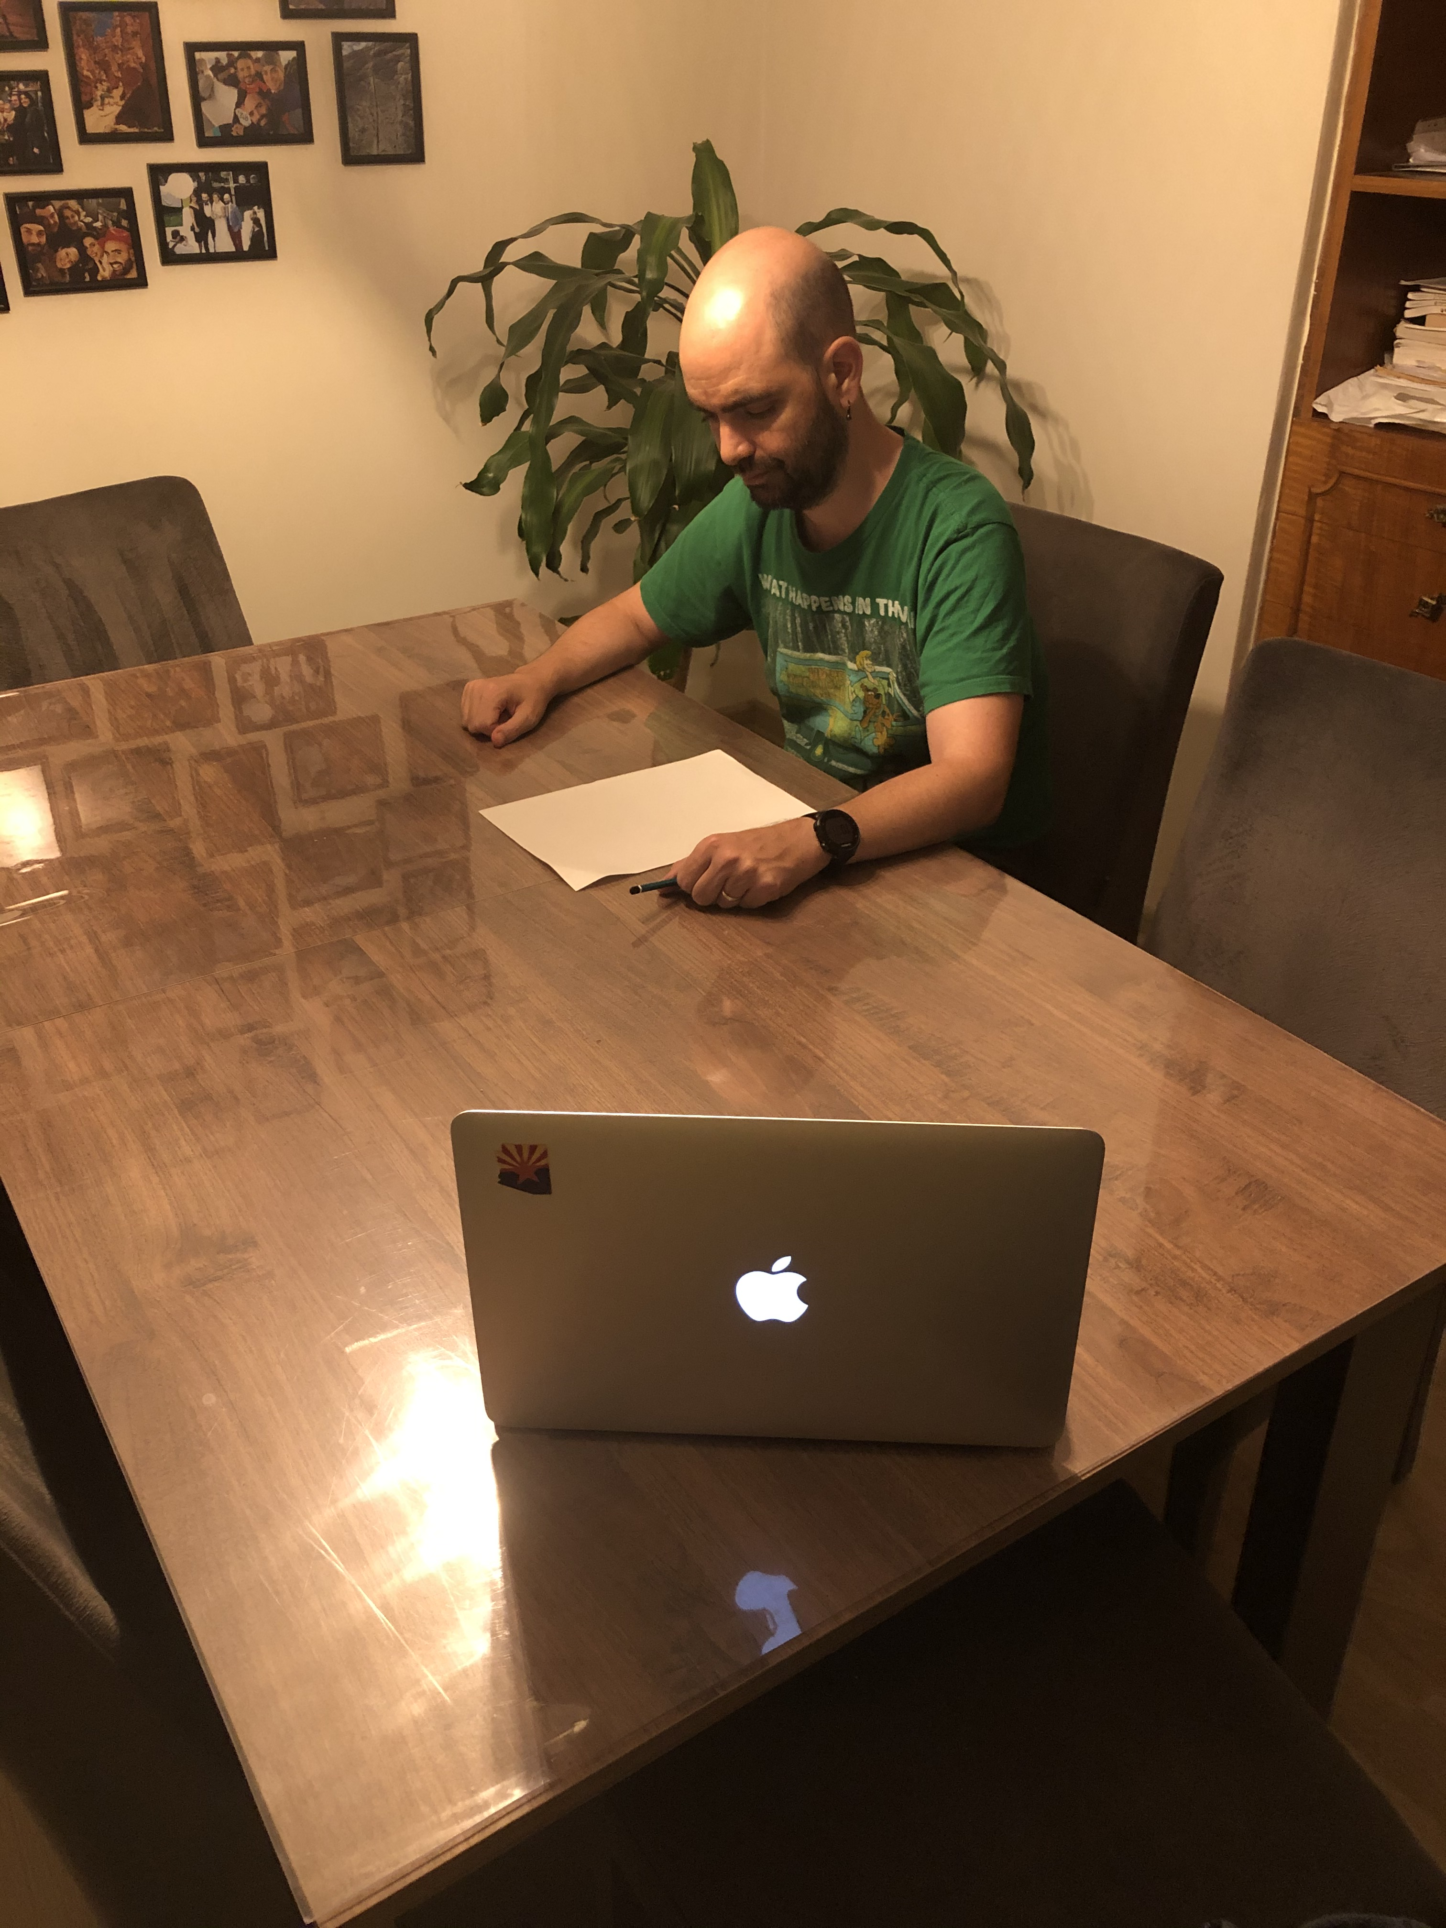

- On the sheet you’ll use for the first 40-minute session, please write before the exam (on the very top of the paper): “I, write your name here, hereby declare that I will not give any help to anybody taking this exam, and I will not use any course sources, materials or take help from others during this exam.” and sign underneath. (You can prepare and sign this before we meet at 12:30)
- The exam will take place in three 40-minute Zoom sessions. You are expected to turn on your camera for us to see you, but all of us will be on mute. You are expected to unmute yourself only if the instructor asks you to do so. In each session, you’ll be shown the questions in big fonts from the instructor’s screen and expected to write your answers on the empty sheet in front of you.
- In the last 5 minutes of each session, you’ll be asked to stop writing and use that time to take a photo of your paper and send it via email to scedmath@gmail.com. So please have a smart phone ready so that you can take the photo and send it via email during the last 5 minutes. We strongly suggest that you use CamScanner (it has a green logo with letters CS). It’s a free app and if you log on with your boun mail address there are certain advantages. The quality is much better than taking a photo. Make sure the file you create is readable. If it is not readable, we’ll ask you to take another photo and send it before the end of the exam.
- Please use the following titles for your emails as their subject: 372 Final Part1, 372 Final Part2 or 372 Final Part3.
- Once you send your response paper for a session, you will not be able to turn back to those questions in the following sessions.
- Make sure your devices are charged (especially the computer you are logging onto Zoom). You might need to plug them in.
- For each 40-minute session, we’ll use the first few minutes for quickly getting started and the last 5 minutes for photo taking and emailing. So the net exam time in each session will be approximately 30-32 minutes.
- In case of poor internet connection and being disconnected from Zoom, please try to log back on immediately (you’re expected to be back within 3 minutes). If your connection is bad, and you log off often and stay disconnected for more than three minutes, you’ll be asked to take a make up exam (an individual oral exam/interview with the instructor) on the date announced officially by the university. So please try to be somewhere with good internet connection.
- We’ll have to record the exam, due to a YÖK announcement sent over to universities on the 22nd of May, asking instructors to document online exams via recording.

